Leaders of PNG province plagued by violence vow to weed out illegal guns
6:48 am on 30 January 2026
Johnny Blades, RNZ Pacific bulletin editor
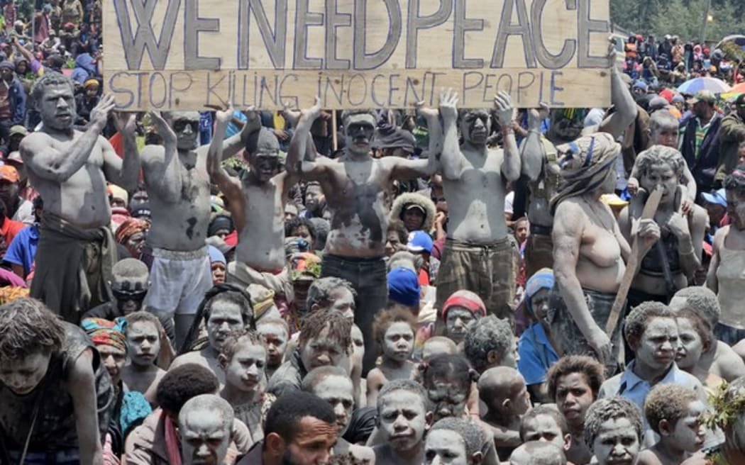
Local villagers hold a placard as they participate in a gathering near the Porgera Gold Mine in Enga province, Papua New Guinea on 23 September 2024, almost one week after police reinforcements were rushed to the area in a bid to quell tribal violence that shuttered the key gold mine Photo: AFP
Political leaders in a Papua New Guinea province plagued by gun violence are making a collective stand to stop it.
There's a new sense of political will among Enga Province's political leaders and police to come down hard on the use of illegal weapons. But they are confronted by a daunting task.

PNG’s Enga province leaders take stand against gun violence
Pacific Waves29 January 2026
Queue
Recent research by Joe Barak of PNG's National Research Institute has tracked the escalation of tribal and election-relate violence in PNG, particularly in the Highlands where the most frequent violent attacks are recorded.
The research shows that Enga Province had the highest number of incidents, 79 between the years 2018 and 2022, or 27.8 percent of the overall number of incidents in the Highlands region during that period.
Prime Minister James Marape this month laid out a 'war on guns'-type plan to crack down on lawlessness in PNG by asserting the authority of the state. But all too often in Enga the authorities have been part of the problem.
Each of the past few general elections have sparked deadly fighting between supporters of rival candidates in at least two of Enga's electorates, with fingers of blame pointed often at political leaders.
Furthermore, there's now more high powered weapons in circulation than ever, and in many cases they are sold by the country's security forces, police and military.
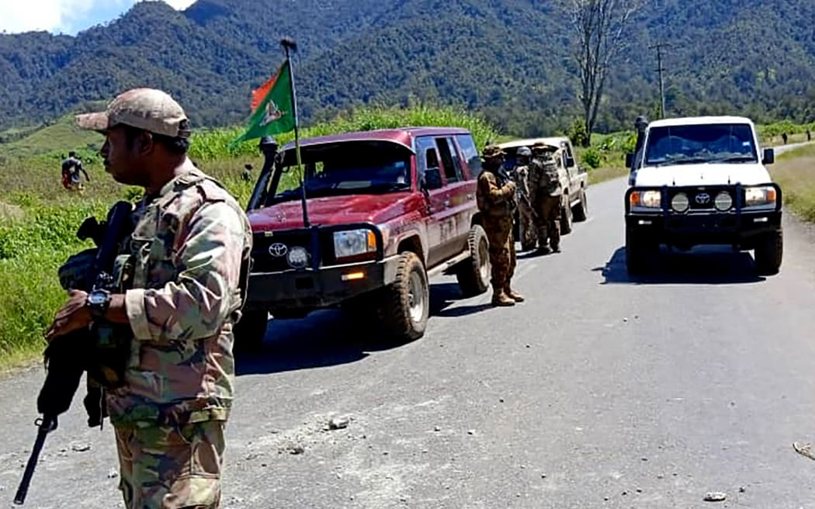
This handout picture released by the Royal Papua New Guinea Constabulary on February 19, 2024 shows officials patrolling near the town of Wabag, 600 kilometres northwest of the capital Port Moresby. Photo: AFP PHOTO / ROYAL PAPAU NEW GUINEA CONSTABULARY
This set of issues is not confined to Enga, but this province has seen the worst of it. A massacre in an Engan village in 2024 which killed at least 49 people was shocking even for a part of the country familiar with tribal warfare.
No respect for authority
Enga's governor Sir Peter Ipatas said people in his province had taken lawlessness to another level using modern guns, with no respect for authority.
"In the past, the tribe used to take ownership and they would discuss whether to fight or not," he explained.
"These days, you have got young people who are on drugs or whatever, causing fights, and a lot of innocent people's lives are at risk, so we need to come up with a tough strategy to identify all these culprits."
Prosecutions have been lacking and this needed to change, Ipatas said, adding that it required police to "actually do their job to make sure that our people who do not respect authority, who break the laws, are investigated and prosecuted properly".
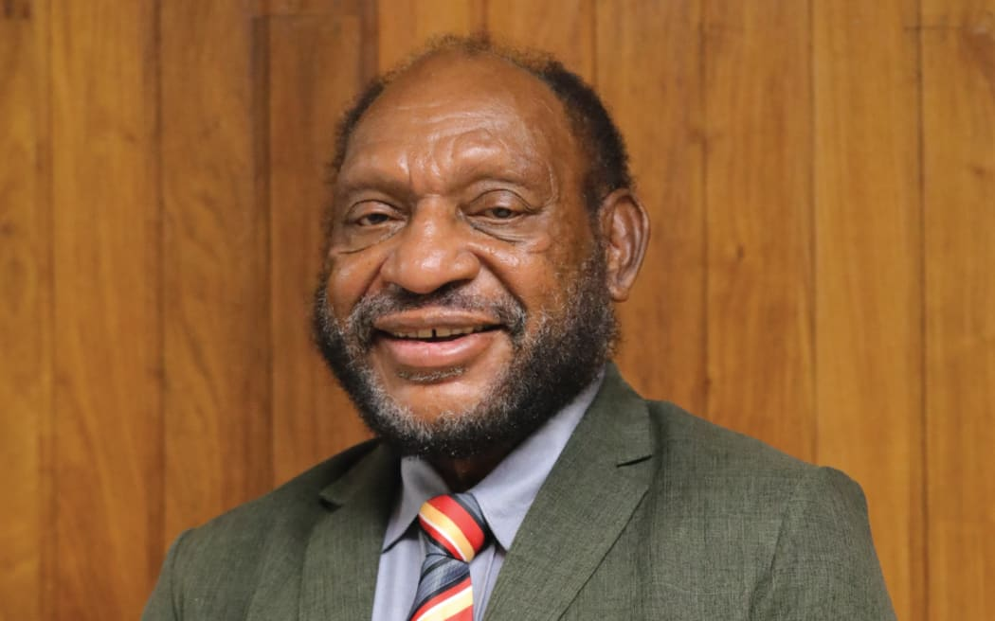
Sir Peter Ipatas Photo: www.parliament.gov.pg
A generally poorly resourced police force has long struggled to deal with social disorder in Enga.
Also Engans have had a lot to deal with themselves in the past couple of years, including landslide disasters, political instability and displacement of communities caused by the Porgera gold mine operations. Through it all, the violence persists.
Lethal force
Earlier this month in Enga's Wapenamanda district, a raid on suspected illegal firearms holders by the elite police Kumul 23 unit resulted in five people being killed.
Despite criticism about alleged deaths of innocent people in the raid, Marape was unapologetic about the use of lethal force to target illegal gunmen
He said this approach would continue because those driving violent conflict through the build-up of illegal weapons had ruined countless lives in this area.
"Wapenamanda was a peaceful district - it's now destroyed," the prime minister said.
However, the former commander of PNG's Defence Force, retired Major General Jerry Singirok, commended Enga's political leaders for finally saying 'enough is enough'.
He said they were taking ownership of their past mistakes, and showing a willingness to get their clans and tribesmen to put down their guns.
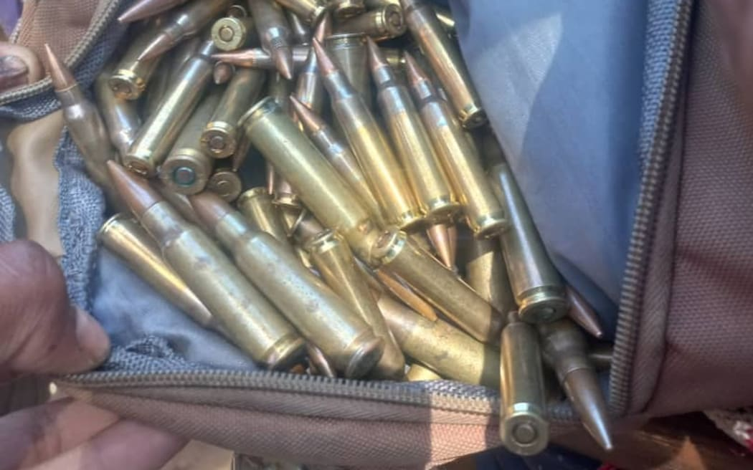
Military issue arms are a fairly recent addition to tribal fighting. Photo: Supplied
Illegal guns
However, before Enga's violence problem can be stemmed, the build-up of illegal firearms needs to be addressed.
General Singirok has been pushing for gun reform in the country for decades. He headed up a UN-backed report into gun violence in the Highlands which was published last year, finding there could be as many as 100,000 illegal weapons in circulation in the region, many of which are sold by police, military and corrections officers.
"I had a particular encounter where a tribesman showed me a pump action shotgun bought from the police force, and the young people on the street said 'well, if you don't have bullets, we buy it from the military and the police'," Singirok said.
"So as part of the crackdown, the government must hold security forces accountable and [serve] heavy penalties on those soldiers who are moonlighting their weapons or selling their weapons or selling ammunition.
"It's very important to cut off the supply chain of weapons and ammunition," he said, noting that security forces needed to enforce command and control, and regularly account for use of weapons and ammunition from their armories.
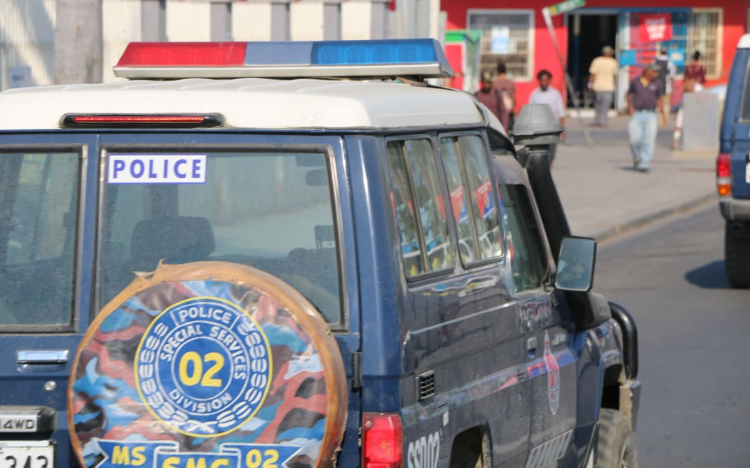
Photo:
The government is looking at a range of options to reduce the massive build-up of illegal firearms across the country, with Marape mentioning a possible amnesty period and a buy-back scheme.
Singirok said the major 2005 gun reform report he authored made clear that incentives are the way to go. He said communities were more likely to give up arms if they know projects that help develop health, education or other services can be established in their area as a result.
Heat on police
Both Singirok and Ipatas said they expected that having an Engan Member of Parliament as PNG's new police minister will help combat law and order problems in the province.
The prime minister appointed one of Enga's veteran politicians, Sir John Pundari, the MP for Kompiam-Ambum, an electorate which has suffered repeated tribal violence since the 2022 national elections.
Firstly, rather than Enga, Pundari had his sights on PNG's capital Port Moresby, where he singled out police senior commanders, saying they need to set an example for the rest of the country by lifting the standard of policing.
"Improve your duty statements, monitor those KPIs, do audit against those KPIs. The deliverables must be visible. The outcomes must be felt. The pride of policing in this country must start from the National Capital District."
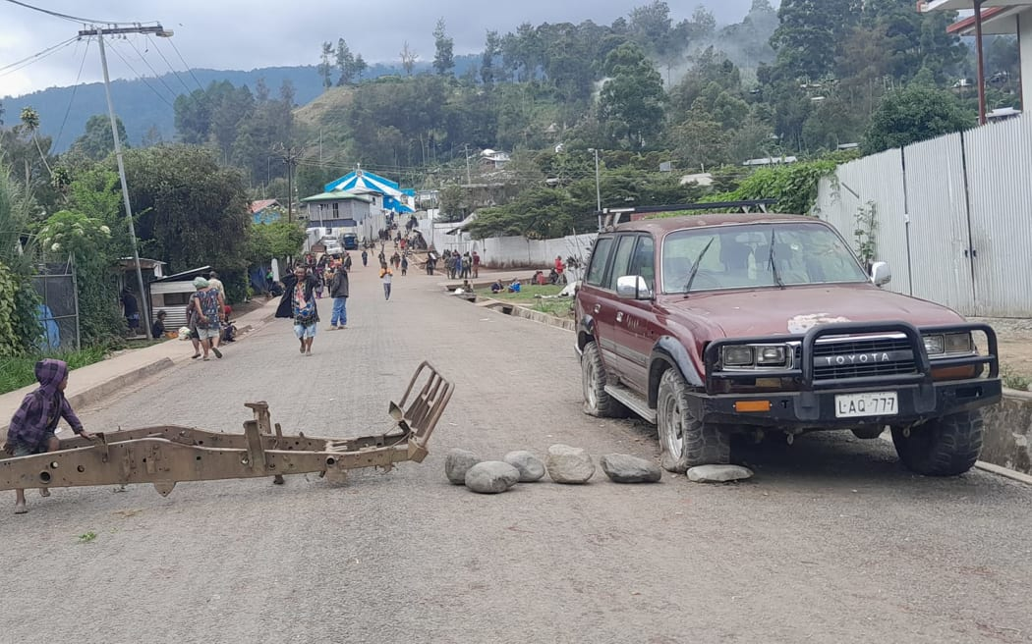
Due to political by-election of Lagaip open, Wabag the provincial capital of Enga is put into a chaotic and a standstill situation. Photo: Facebook.com/Paul Kanda
Pundari's message may have been corporate in language, but it reflected hopes of many Papua New Guineans: for police to simply do their job.
To do their job they need to be properly resourced - that has not always been the case. It will have to be if police are to stop the fighting, the massacres and political vendettas in Enga.
Pundari is pushing for the death penalty to be brought back to deter violent crimes in the country.
PNG's political class is sounding deadly serious about ending gun violence, but the 'big men' will have to lead by example.
As far as Enga is concerned, the true test of that commitment will come in next year's general election.

