News|Mining
Tribal violence over Papua New Guinea mines kills at least 20: UN
As clashes in Porgera Valley intensify, authorities allow police to use ‘lethal force’ to quell violence.
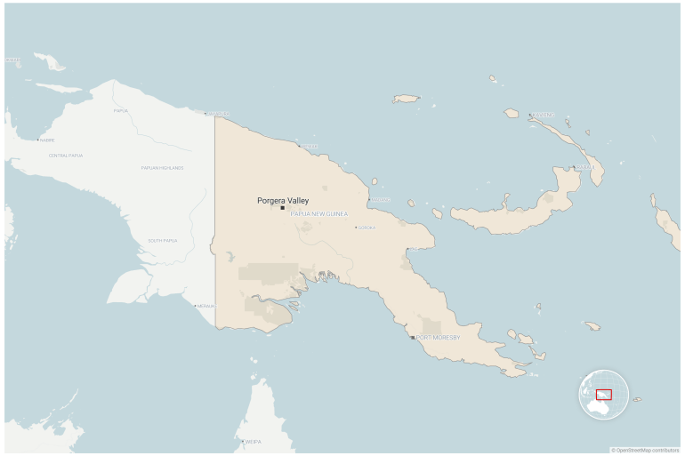
Clashes between rival tribes near a gold mine in Papua New Guinea’s Porgera Valley have killed 20 to 50 people, according to the UN [Al Jazeera]
Published On 16 Sep 202416 Sep 2024
Papua New Guinea has given police permission to use “lethal force” to restore order as shootouts between rival tribes have killed dozens of people.
Between 20 and 50 people have been killed in the violence in the Porgera Valley in Enga province, home to one of the country’s largest gold deposits, the United Nations estimated on Monday.
The fighting involving hundreds of tribal warriors, apparently over control of local mining access, is continuing, the government said. The violence has spiralled after an attack in August on a landowner in the area by unauthorised miners, police said as they reported that 300 shots had been fired the previous day.
Mate Bagossy, the UN’s humanitarian adviser for Papua New Guinea, said the death toll from the intensifying tribal conflict had reached “at least 20” on Sunday but was “likely up to 50 people” based on information from community members and local authorities.
“Today, some security forces have started moving in,” Bagossy said on Monday, adding that “it remains to be seen what effect this will have”.
Police reported 30 men had been killed across the rival clans, hundreds of women and children displaced and “many” homes burned to the ground. The use of “lethal force” has been sanctioned to try to quell the violence, according to Police Commissioner David Manning.
“Put simply, this means if you raise a weapon in a public place or threaten another person, you will be shot,” Manning said in a statement over the weekend, adding that “illegal miners and illegal settlers” were “victimising” traditional landowners and terrorising local communities.
According to police, unauthorised miners from the Sakar clan have been squatting on land owned by their Piande rivals.
Alcohol sales have been banned and an overnight curfew is in place, Manning added. He promised to remove the miners from the valley, which is located near the site of a landslide in May that was estimated to have killed more than 2,000 people.
‘Spiral of violence’
Tribal conflicts are a frequent occurrence in Papua New Guinea’s highlands, but an influx of automatic weapons has made clashes deadlier.

Get real-time breaking news alerts and stay up-to-date with the most important headlines from around the globe.

The latest burst of fighting had been turbocharged by the presence of more than “100 high-powered weapons in the wrong hands”, police said.
The Porgera gold mine once accounted for about 10 percent of Papua New Guinea’s yearly export earnings.
But recurrent flare-ups of tribal violence and a drawn-out government takeover have slowed production in recent years.
Gunfights between rival clans living near the mine killed at least 17 people in 2022.
And at least 26 people, including 16 children, were killed when three villages in East Sepik province were attacked this year.
Pope Francis urged Papua New Guinea to “stop the spiral” of violence during a visit this month.

