Kup Women for Peace continues to promote peacebuilding and address Gender-Based Violence (GBV)
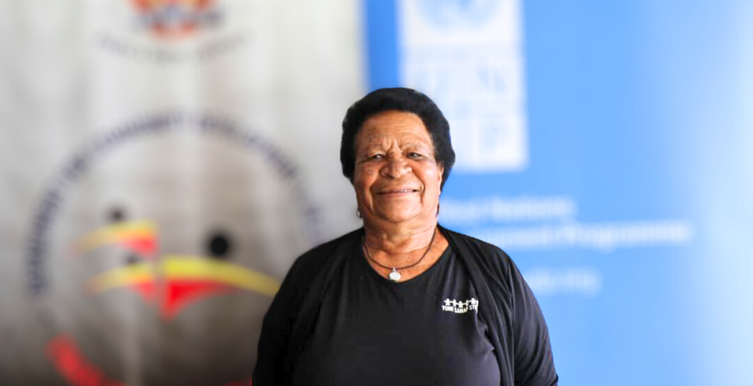Ms. Angela Apa, President of the Kup Women for Peace group. Photo: Lydia Kaia | UNDP Papua New Guinea
May 3, 2023
SIMBU, Papua New Guinea - Kup Women for Peace (KWP) is a community-based organization based in Simbu Province, that has been working alongside formal and traditional structures of leadership to change attitudes about both violence and women’s roles in society since 1999.
Kup Women for Peace is a recognized and respected partner in the informal coalition of people addressing family and sexual violence and sorcery accusation related violence, engaged in peacebuilding, and promoting and protecting women’s rights and security.
They form a strong group of advocates who play a critical role in promoting peacebuilding, reducing conflict, raising awareness, and taking action against Gender-Based Violence (GBV) and Sorcery Accusation Related Violence (SARV).
In January 2023, the CBO reunited a little girl with her family after two years of separation and, after extensive work, facilitated the halting of a tribal conflict between two warring tribes in Papua New Guinea’s Chimbu Province.
These are just two examples of conflict Kup Women for Peace has been able to resolve at the community level, which has been made possible with grant funding from the Department for Community Development and Religion (DFCDR) in partnership with United Nations Development Fund.
In December 2022, they joined 12 other civil society organizations (CSOs) as recipients of grants to support efforts to address GBV and SARV at the community level. This support is co-funded by the National Government and the Spotlight Initiative, which is a part of a global partnership between the United Nations (UN) and the European Union (EU) that is committed to ending violence against women and girls in Papua New Guinea.
Notably, in 2022, DFCDR was allocated 7.93 million Kina for the first time ever to address GBV and SARV through partnerships with CSOs. Providing direct grants to CSOs who already have the networks and knowledge to effectively engage with local communities is a major part of DFCDR’s strategy to address GBV and SARV more effectively.
Ms. Angela Apa, a Human Rights Defender and president of the group, said the support allowed them to engage and lobby for leaders from the provincial government to act. In the case of the fighting between the Damba tribe and the Kombtnagike and Mingaku clans from Jimi during an election dispute in July 2022. This was further aggravated by a dispute that resulted in armed confrontations between the neighbouring communities. The conflict led to intense fighting, loss of property, disrupting schools, destroying food gardens, and forcing markets to close, limiting income generating opportunities for families.
"My officers and I were able to pay a visit and access the living conditions of the 26 families affected by the conflict from the Jimi side. We were appalled by what we saw, and it was sad to see the rise in sickness, skin infections, and poor nutrition. Women and children were affected the most", said Angela.
"Luckily, the crisis response funds allowed us to respond to this need. We were able to purchase food, medicine, and much needed supplies for the families."
-- Angela Apa, Kup Women for Peace
Angela and her team were then able to get support from provincial leaders who attended the event with pigs, and food was exchanged between the two tribes.
Kup Women for Peace CBO continues to conduct awareness-raising programmes and projects that have helped bring peace and reconciliation among the communities.
These women emphasize that while the perpetrators of violence are mostly men, there are many fathers and sons who disagree with the violence and who stand up to stop it.
In another case, a 5-year-old girl was brought to Chimbu from Lae, Morobe Province. She was left homeless after her guardian passed. She moved from home to home before she was taken in by a good Samaritan and her son, who reached out to Angela and her team.
After almost two years, with the help of Family PNG, Lae Police’s Family Sexual Violence Unit, and KWP, she was returned to her parents. It was a bittersweet moment as she embraced her mother, surrounded by all these women who had come together to ensure her return. She has been receiving care and support from the Angau Memorial Hospital and the Family Support Centre.
Angela says that KWP has been able to support these two significant incidents with the grant funding made available in December 2022 and will continue activities to respond to SARV and GBV.
KWP will continue to contribute to improved coordination of referral services and capacity building for quality support services for survivors of violence against women and girls, those accused of sorcery, and their dependent family members. Their efforts have been bolstered by the support provided under the grant.

The story was originally published on PNG National GBV Secretariat website and UNDP PNG website.

