First Interview
Engan Tribesmen walking towards a recent village that they had attacked.
Tribesman 1 English: “Sir, come over here. This house was burnt. Also, there is the garden that we destroyed, up there.”
Tribesman 2 English: “I burned this house.”
Tribesman 3 English: “We burned this house.”
Tribesman 4 English: “So we are the winner!”
Tribesman 5 English: “We are fighting for the ground, or we are fighting for pig, or we are fighting even for the men who died fighting.”
Tribesman 6 English: “Now we want to go and kill. So we can sort it now. Otherwise they [unintelligible] will kill us too”
Tribesman 7 English: “We will kill, we will kill … we kill”
Tribesman 4 English: “Our fighters still want to… we want to … others kill … so you can stop and you can go.”
Second Interview with tribesmen who killed around 100 people of a nearby village and left their bodies on the road. At weapons stash.
Tribesman 1 English: “You will meet the combat team.”
Tribesman 2 English: “You are all there?”
Tribesman 3 English: “Yes”
Tribesman 4 Engan Language via interpreter: “These are the latest M-16 model. Its very powerful and costs almost €10,000 euros on the black market. It wasn’t easy to buy. We had to save money for years. That day on the battlefield, our enemies attacked us first. But I managed to kill 60 people with this gun. My men killed 40 others. But 60 people is a small number. If they come back, I will kill 60 more.
Tribesman 5 Engan language via interpreter: “They are my enemies. So if I see them, I will cut them down.
Third Interview. Note: These people from another valley know the toll that the fighting can take on a community.
Tribesman 1 Engan Language via interpreter: “They shot me here and the bullet came out from there.
Tribesman 2 Engan Language via interpreter: We were in a gunfight and we ran out of bullets. So they caught me and cut my nose with a bush knife (Machete). I tried to escape, but I tripped on a rock and lost my teeth.
[interviewer: “Here, hatred between rival tries stretches back generations. Revenge is about protecting their honour above all else. Children are taught to hate their enemies from a very young age.]
A tribeswoman holding her 2-year-old suckling child had an older son who was killed by fighting:
Tribeswoman 1 Engan Language via interpreter: “For as long as I am alive, I will encourage myself to take revenge. I will tell him [her 3-year-old son] to kill more of our enemies. This tribal fight will never end. Even our sons, the next generation, will remember, and fight to take revenge.@

Note: the villages buried by the landslide were previously caught up in the ongoing tribal violence, but now it is weakened and there are not enough men left to defend it, making it vulnerable to neighbouring tribes.

Valka-Mir Foundation
Speakers
Speaker 1 (100%)
Dania, you're not far from where this massacre is reported to have happened. What can you tell us about it? Janice, I'm in Wabag Town, which is the capital of the Engan province. And the fighting zone is in Wapenamanda District, which is about 20 to 30 minutes east from here. I drove through the fighting zone about an hour ago. There's no sign of any actual conflict from the road, but there's a really heavy police and army presence. I'm told that we're going upwards of 50 people that have been killed from both sides. There's 17 tribes involved in this particular dispute. And it's been, it's been told that it's the biggest, it's the biggest fight of its kind in anyone's experience or memory. Police are combing the bush for more bodies. There are reports that some have been washed away in the river. There's a lot of fast flowing rivers around here, people fleeing the fighting. So it's going to be some time before we know the true numbers of the people whose lives have been lost in this conflict. That's an absolutely devastating picture that you're painting there, Tanya, and you've been speaking directly to Enger Province Governor, Sir Peter epitas. What's he saying about this incident? Yes, I spoke to the governor about 20 minutes ago, and he pointed out that this is actually not a normal kind of tribal fight. He says there appears to be a new pattern developing in the way that these what are normally traditional tribal fights, and you know, disputes are conducted up here. He said the traditional rules for tribal fighting not being adhered to. He maintains that unless our police force, which he wanted to emphasize, is the government's trusted and enforce, entrusted enforcement law law enforcement agency in Papua, New Guinea, we need an efficient and effective police force, and if we don't get that, we were going to continue to see such trouble, such trouble. He's been very vocal about this over at least six to eight years, consistently calling on the national government to get serious about capacity building in our police force, as well as to get the culture right. And his solution has always been, and he's made many calls about this, is to bring Australian police force in in large numbers to work on the ground alongside Papua New Guinea's law enforcement agencies to mentor our young new recruits. He pointed out that we get new recruits in but unfortunately that they lack mentorship and the instilling of proper policing culture. I want to talk more about what's fueling this spike in violence, because we know that Engen was put into lockdown for months last year over this conflict that's rising. What do you think is fuelling the violence, and where are these weapons coming from? Yeah, so this flare up that's going on right now is a continuation of a fight that actually started in around April of last year, 2023 and then it flared up again in August, again, last of 2023 that's when they, they brought the lockdown in, and it's, it's retribution over the death of a person. So often it can be these fights can be a simple thing, like a fight over a game of pool and and then it can escalate very quickly, and the end, unfortunately, can drag on for years, in fact. So what is concerning is that before we didn't see the we didn't see the high number of weapons, which she pointed out, it's believed actually in this particular dispute, since it began in April, over 150 lives have been lost, which is horrifying. And these elite, these guns, the governor said these are illegal guns. He has no idea how they're coming in, but he says that they're clearly being supplied by people who are well to do, he says, people with the means and the funds to buy them. He wanted to point out that the villages here and the tribes people here simply don't have the means to buy guns or bullets. And he said that in terms of where they're coming from, it again, it comes back to police force, not having the capacity and not not being able to do their jobs properly to weed out the sources of the weapons that are coming into the highlands and making their way into these tribal disputes. So where to from here? Tanya? Because you're saying that people are describing this as the worst outbreak of violence in p and G's recent history. We know that troops are already deployed there. You're talking about a situation where authorities are losing control. So what are authorities saying they're going to do to contain and prevent further bloodshed? I wouldn't be surprised if they they bring in another lockdown, because that then just controls the Restrict and restricts the movement of people, so then it's easier for them to to then go in and you Apprehend people who apprehend the people that they need to apprehend. There was a statement put out by the opposition, who are also questioning the guns, questioning very heavily, where are these guns coming from? The police are frustrated because, quite frankly, the kind of weapons that are being used in a tribal fight. They're better armed than the police force in some instances. So there has been calls and the government, the PNG government, has spoken recently about working with Australian police to come in and help build capacity, because that really is the solution. It's just a matter of how and when they do it. And again, the governor from Enga believes that we don't need just a couple of police coming in here. We need them to come in large numbers. Tanya Nugent, thanks so much for the update. You.
Summary of Findings on Witch Accusations and the Church
This paper summarizes and responds to critiques and commentaries from various scholars regarding witch accusations and the Church, drawing insights from anthropology, theology, and human sciences. The key findings highlight the complexity of witch accusations, their negative consequences, and the role of different theoretical frameworks in understanding them.
Functionalist Perspectives and their Limitations
- Initial Functionalist View: Early anthropological treatments often adopted a functionalist frame, viewing witchcraft accusations as serving a social function, such as releasing stress or maintaining harmony within communities by accusing vague, distant witches [1].
- Critique of Functionalism: The paper challenges the idea that witch ontologies necessarily have positive social outcomes. While some functionalist arguments suggested that accusations against distant witches could prevent internal conflict, further research, particularly concerning the Navaho, revealed that accusations often involved close relatives and had severe negative consequences for the accused [2] [3].
- Negative Outcomes for the Accused: Contrary to functionalist views, the research, including studies in Kinshasa, emphasizes the devastating impact on those accused, such as torture, burning, hunger, and expulsion from their families [4] [5]. This perspective places the accused and the negative outcomes at the center of the analysis.
Psychological and Feminist Analyses of Accusations
- Psychological Dynamics: Psychological analyses, drawing on concepts like unconscious projection and scapegoating, are crucial for understanding witchcraft accusations. Some scholars suggest shifting focus from the accused to the accusers, examining their motivations and potential "pathological narcissism" [6].
- Self-Serving Motivations of Accusers: Accusations can stem from self-serving and flawed motivations, such as relieving oneself of responsibility for an unwanted dependent or appropriating marital assets. This highlights that instrumental considerations can influence the accusing process [7].
- Feminist Critique: Feminist perspectives view witch accusations, particularly against women, as exemplifying victimization rather than serving a functional purpose. They highlight that women, especially elderly and poor ones, are disproportionately accused worldwide [8]. The issue of "unwanted children" is also linked to patriarchal societies, where children who do not fit into family settings may be accused of witchcraft to justify their removal [9].
Epistemological and Theological Considerations
- Questioning Truth Claims: Epistemology addresses how truth is established in witch accusations. The paper emphasizes that simply believing something is true does not make it so, especially when accusations have severe consequences, such as claiming someone murdered another through witchcraft [10].
- Role of Diviners and Prophets: In societies with witchcraft ontologies, traditional belief systems often include diviners or witchdoctors who claim preternatural abilities to identify witches. However, the paper notes that even in Christian contexts, some prophets and pastors adopt similar roles, claiming to identify witches, which raises questions about the epistemological basis of such claims [11].
- Flawed Evidences and Confessions: The paper highlights that supposed proofs for witchcraft, such as dream content or confessions, are often epistemologically flawed. Confessions, frequently obtained under duress or torture, are central to witch ontologies but can be influenced by cultural cues and prior suspicions [12] [13]. The historical repudiation of witch trials in Europe was partly due to the recognition of these flawed proofs [14].
- Scriptural Interpretation: The paper discusses how the Bible has often been mistranslated or misinterpreted to support witch ontologies. It argues for a careful re-examination of biblical texts, as many scholars contend that no biblical text teaches the idea of "witchcraft" where people cause misfortunes through evil occult power [15].
Metaphysics and Worldviews
- Witchcraft as a Core Imaginaire: Witchcraft ontologies are deeply embedded in the social and cultural imagination of many communities, particularly in Africa. This "spiritualized imagination" is often seen as central to the growth of Christianity, posing questions about whether Christian growth requires the preservation of such beliefs [16].
- Challenge to Worldviews: The paper advocates for a "frontal challenge to the worldview" that sustains witchcraft beliefs, rather than merely addressing the symptoms. It suggests that while individual pastoral responses can help, a deeper critique of the underlying metaphysical framework is necessary [17].
In conclusion, the paper underscores that witch accusations are a multifaceted issue requiring interdisciplinary approaches. It calls for a critical examination of functionalist, psychological, feminist, epistemological, and theological frameworks to understand the dynamics, address the negative consequences for the accused, and move towards more biblically sound and contextually relevant responses.

Kainantu tribes end deadly feud with peace signing at NSI
Monday, 16 June 2025, 11:00 am
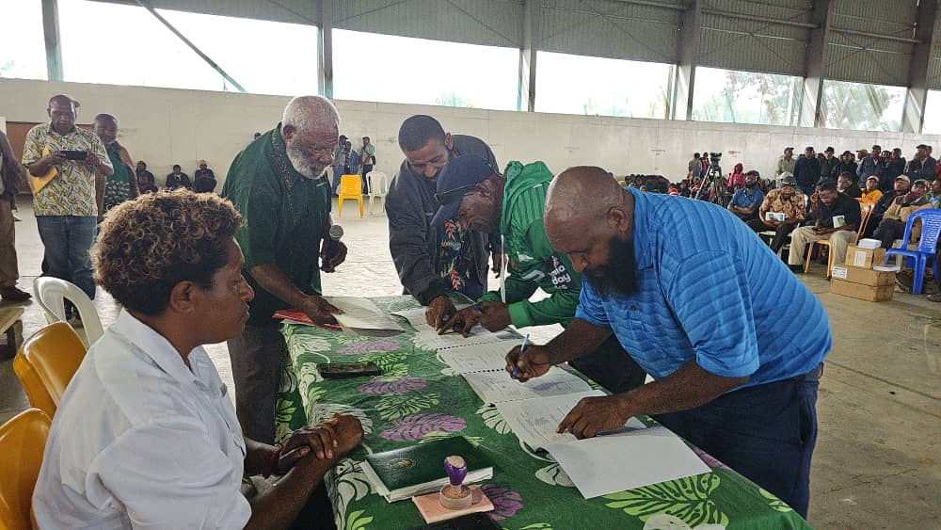Leaders from the AzuNofi tribe of Barola signing the Peace Agreement at the National Sports Institute in Goroka. (NBC News)
Two warring tribes from the Barola section of the Highlands Highway in Kainantu District have officially ended months of deadly conflict by signing a peace agreement at the National Sports Institute [NSI] in Goroka.
The Stone Famo and AzuNofi tribes of Kamano 1 Local Level Government had been locked in violent clashes since December last year. The conflict, rooted in sorcery accusations, resulted in the loss of lives, destruction of homes, gardens, and properties, and posed a serious threat to public safety along a key stretch of the national highway.

Last Thursday, a powerful scene unfolded at NSI as over 20 trucks and buses carrying members from both tribes, along with their leaders, converged for the historic peace ceremony.
The peace accord was formally witnessed by Henganofi MP Robert Atiyafa, who is also Chairman of the Eastern Highlands Provincial Law and Order Committee, Kainantu MP William Hagahuno, Provincial Police Commander Chief Superintendent John Kale, Church leaders, ward councilors, and provincial government officials.
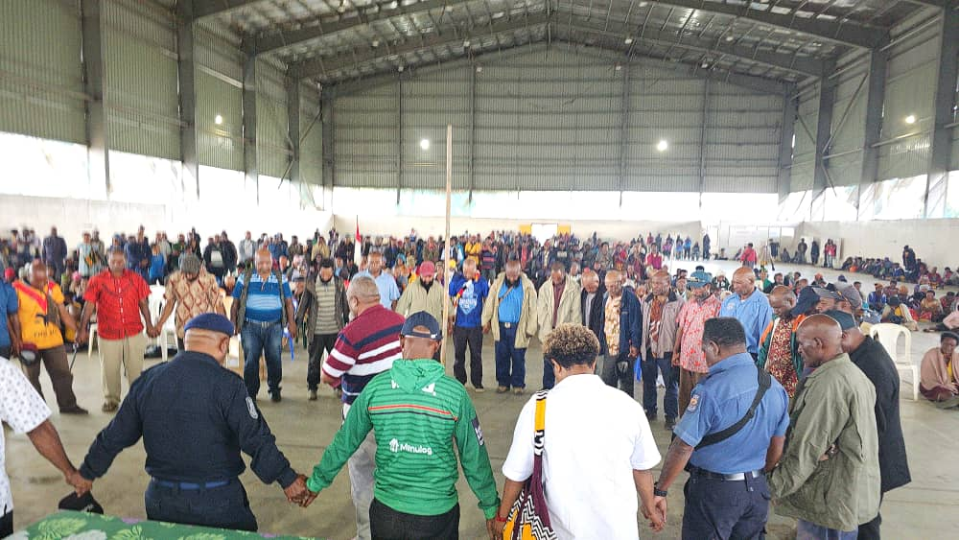
MP Atiyafa praised the collaborative efforts that led to the reconciliation.
“I thank the churches, village leaders, and police for their courageous actions in engaging with the community to stop the violence,” he said.
“You live along the National Highway and we all want that highway to remain safe and free for everyone.
“Thank you for your hard work in bringing peace back to Barola.”
A symbolic highlight of the event was the distribution of Bibles by the Seventh-day Adventist Church, signifying repentance, forgiveness, and unity. Both tribes came forward in a public act of reconciliation, acknowledging past wrongs and committing to peace.
The peace agreement is a step towards rebuilding trust, restoring order, and ensuring the safety of one of Papua New Guinea’s vital transport routes.

