90,000 displaced since May, 25,000 children unable to attend school
Fighting since country’s election in July has continued in the highlands, with women and
Rebecca Kuku in Port Moresby
Wed 28 Sep 2022 02.50 EDT
An estimated 90,000 people have been displaced by violence in the highlands of Papua New Guinea since May, with about 25,000 children unable to attend school and reports of rape, kidnapping and other violence, say the UN and local officials.
The fighting has been related in many cases to the recent national elections, in which around 50 people were killed and schools and other public buildings burnt down.
“While in some cases, there are residual disputes over election results that are triggering sporadic violence, in other cases, such as in Porgera, the root causes are due to other reasons, and the instability of the election period was capitalised upon to reignite old disputes,” said Themba Kalua, UN resident coordinator and UN women country representative.

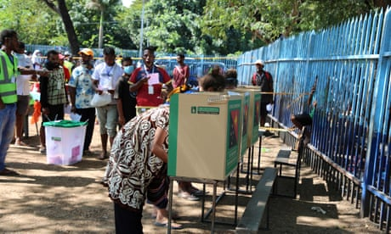
Kalua said that the UN estimates about 265,000 people had been affected by the 2022 general election-related violence in Enga, Southern Highlands and Hela (Highlands Region), leaving almost 90,000 people displaced.
“The displaced persons are primarily women, children, people with disabilities, and the elderly who have been displaced from their communities while non-disabled men remain and fight. The challenge in getting a precise count remains as displaced persons frequently move about due to ongoing security concerns or in search of resources.
“Women and children are the most affected. An estimated number of 25,000 learners are unable to attend school as schools in the affected areas remain closed. At least 70 women and girls now have been victimised by rape, kidnapping, or sorcery accusation-related violence.”
Porgera crisis management coordinator, Nick Pakea, who is also the president of the Porgera Chamber of Commerce, said more than 60,000 people from Porgera Paiela in Enga have been severely affected by election-related violence and tribal fights.

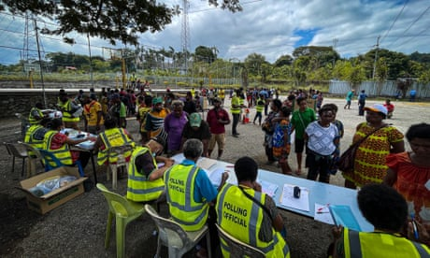
Pakea said the troubles began when the Porgera mine was closed down, and worsened during the election when security forces were sent in to extract the 2022 general election ballot boxes.
“More than 20 clans … clashed. Sixty thousand people were displaced, with many families fleeing to Mt Hagen in Western Highlands for refuge,” he said.
“Those who do not have the means to seek refuge elsewhere are here. Our women and girls are left very vulnerable to sexual assaults and attacks. Our children are not attending schools.”
“We have not received any support from the district, provincial or national government or from the US and UN as reported. Maybe help is still on its way, but on the ground, we have yet to see that help,” he said.
The US government, through its international development agency USAID, provided $3.1m to support displaced persons and survivors of violence in the affected areas. This was in addition to the $100,000 donated in July for immediate humanitarian assistance.
The United Nation’s Population Fund have also been supporting women and children affected by the violence in the highlands and distributing reproductive health kits, but it says challenges in reaching communities have been immense.
“Schools and health facilities were also badly affected by the election-related violence. Rural health centres are severely understaffed and facing shortage of basic medicines. But the roadblocks [that have] been set up have remained one of the main challenges affecting our ability to reach the most vulnerable in the communities.”
Meanwhile, police in PNG have also set up a taskforce investigating team with 40 investigators to look in election-related violence.

